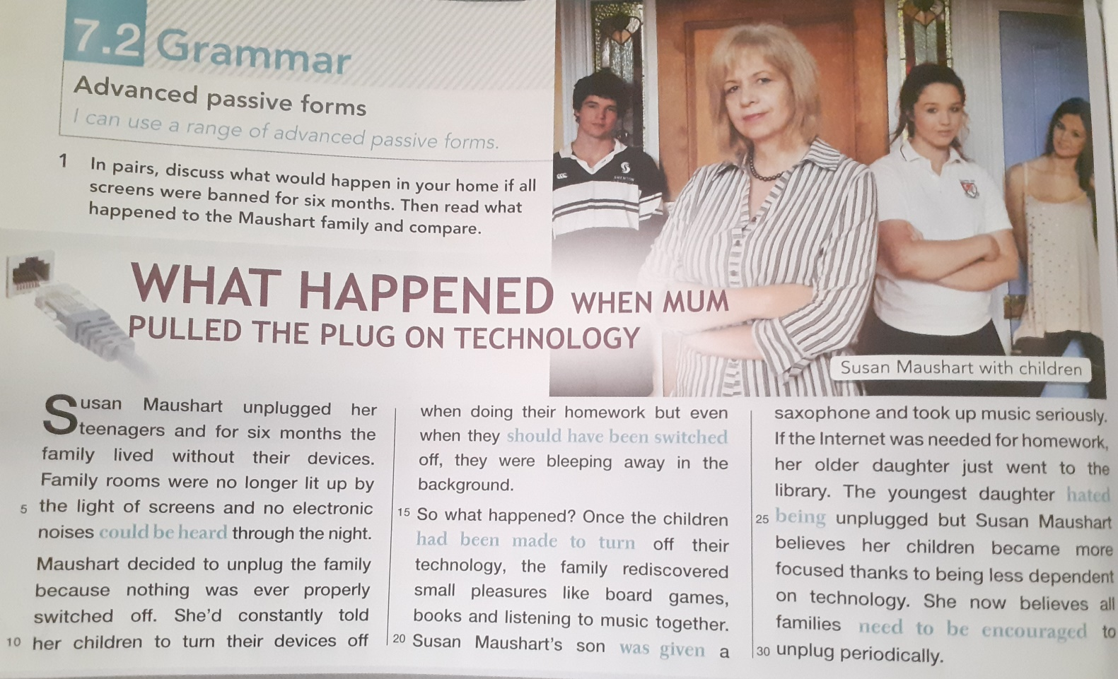
Read the text and answer the question.
1.What did Susan Maushart do ?
2.Why did she decide to unplug the family ?
3.What did the family rediscover?

